**Exercise 1: Control Structures**

**Scenario 1:** The bank wants to apply a discount to loan interest rates for customers above 60 years old.

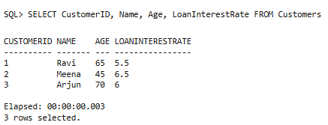

**Scenario 2:** A customer can be promoted to VIP status based on their balance.

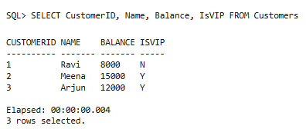

**Scenario 3:** The bank wants to send reminders to customers whose loans are due within the next 30 days.

